Essay Exercise –
The significance of nuclear fission to modern warfare

Nuclear fission is one of the most fundamental processes of nuclear physics and one which is responsible for the deadliest weapon known to man. The discovery of nuclear fission is credited to the German scientist Otto Hahn who in December 1938 reported that he had detected the element barium after bombarding uranium with neutrons. Following this, two exiles from Nazi Germany, Lise Meitner and Otto Frisch, realised that Uranium 235 could be used in a fission reaction and that the energy released from this reaction was much larger than any other physical process.

The process of nuclear fission produces vast amounts of energy by exploiting the energy difference between unstable nuclei of heavy atoms and the more stable nuclei of lighter elements. Nuclei of heavy elements which do not have a fine balance between the number of protons and neutrons in its nucleus undergo fission reactions to form two comparable lighter and more stable nuclei.

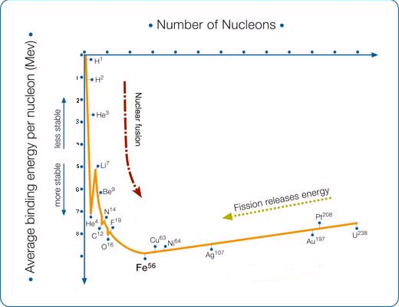

Fig. 1: Fission works by taking advantage energy difference between the ‘coulomb valley’ (heavy elements) and the stable iron element (about 1 MeV). Fission exploits this energy difference by breaking the large nucleus into two lower energy pieces thus releasing energy.

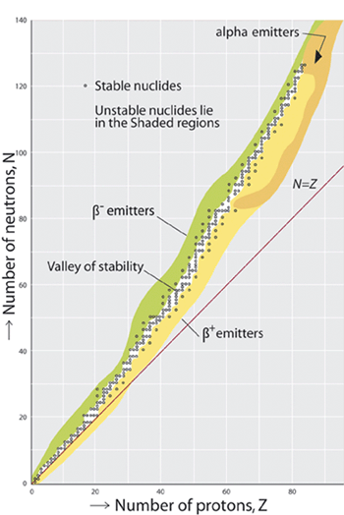
The stability of a nucleus lies in the balance between the number of neutrons and protons it contains. Since both protons and neutrons are Fermions they obey Pauli’s Exclusion Principle, therefore equal numbers of the two produces a stable isotope. However, for heavier isotopes a few more neutrons than protons produces the most stable nuclei. The extra neutrons are able to ‘dilute’ the increased electric repulsion from the high number of protons therefore producing more stable isotopes. Some heavy elements such as uranium have unstable nuclei due to insufficient neutrons available to overcome the electrical repulsion of the many protons and therefore undergo fission reactions.

Fig. 2: Stable and unstable nuclei.

The continuous fission reaction is known as a chain reaction and the mass at which fission becomes self-sustaining is referred to as the critical mass. A fission reaction is self sustaining and will carry on at a steady rate if on average one neutron from fission produces a further fission reaction. The critical mass is the smallest amount of fissile material required to sustain a chain reaction. A numerical measure of a critical mass is dependent on the neutron multiplication factor, k, where: k = f − l, where f is the average number of neutrons released per fission and l is the average number of neutrons lost. When k = 1 the mass is critical.

Enrico Fermi produced the first fission reactor on December 1942 and was able to keep the fission reaction going using the concept of critical mass. This led to the setting up of the Manhattan project by the American government as calculations suggested that the critical mass could be enhanced to produce nuclear bombs. The Americans used the first nuclear bombs on the cities of Hiroshima and Nagasaki in 1945 with devastating effect. Undoubtedly the production of fission bombs has changed the face of modern warfare as the potential destruction posed by nuclear bombs has led to a more conservative approach to confrontation by nuclear powered nations in a bid to avoid annihilation in a nuclear war.

(Word Count: 533 words)

